**Kloklezen**

……………………………………….

……………………………………….

……………………………………….

Dagelijkse (reken)kost : maandag 20 april

**Tafelrijtjes**

|  |  |
| --- | --- |
| 9 x 2 = ……. | 16 : 2 = ……. |
| 5 x 2 = ……. | 20 : 2 = ……. |
| 3 x 2 = ……. | 2 : 2 = ……. |
| 0 x 2 = ……. | 4 : 2 = ……. |
| 7 x 2 = ……. | 8 : 2 = ……. |

|  |
| --- |
| ***Optellen en aftrekken tot 100*** |
| 45 + 4 = ………….…………………….………… |
| 67 + 6 = ………….…………………….………… |
| 83 + 9 = ………….…………………….………… |
| 98 - 2 = ………….…………………….………… |
| 83 - 6 = ………….…………………….………… |
| 54 - 5 = ………….…………………….………… |
|  |
|  |
|  |
|  |
|  |
|  |
|  |

**Los al cijferend op.**

**Schat tot op het honderdtal!**

|  |  |  |  |  |
| --- | --- | --- | --- | --- |
| 185 + 414 = | | | | |
| ……….…………… | | | | |
| **TD** | **D** | **H** | **T** | **E** |
|  |  |  |  |  |
|  |  |  |  |  |
|  |  |  |  |  |
|  |  |  |  |  |
|  |  |  |  |  |
|  |  |  |  |  |

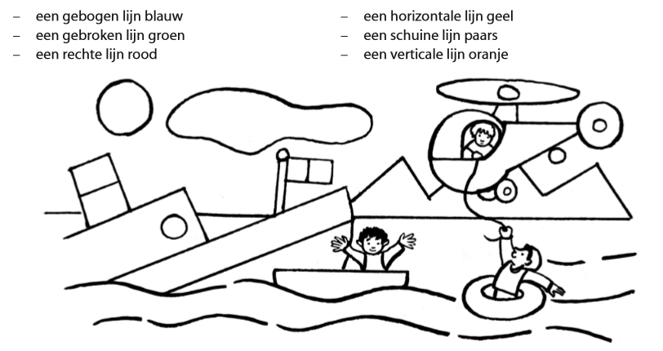

**Kloklezen**

……………………………………….

……………………………………….

……………………………………….

Dagelijkse (reken)kost : dinsdag 21 april

**Tafelrijtjes**

|  |  |  |  |
| --- | --- | --- | --- |
| 3 x 3 = ……. | 30 : 3 = …… |  |  |
| 5 x 3 = ……. | 24 : 3 = …… |  |  |
| 9 x 3 = ……. | 12 : 3 = …… |  |  |
| 2 x 3 = ……. | 3 : 3 = …… |  |  |
| 7 x 3 = ……. | 18 : 3 = …… |  |  |

**Schrijf tussenstappen!**

|  |
| --- |
| ***Optellen en aftrekken tot 100*** |
| 23 + 32 = ………….…………………….…………………….… |
| 14 + 51 = ………….…………………….…………………….… |
| 24 + 38 = ………….…………………….…………………….… |
| 64 – 22 = ………….…………………….…………………….… |
| 88 – 65 = ………….…………………….…………………….… |
| 84 – 81 = ………….…………………….…………………….… |
|  |
|  |
|  |
|  |
|  |
|  |
|  |

**Los al cijferend op.**

**Schat tot op het honderdtal!**

|  |  |  |  |  |
| --- | --- | --- | --- | --- |
| 779 – 158 = | | | | |
| ……….…………… | | | | |
| **TD** | **D** | **H** | **T** | **E** |
|  |  |  |  |  |
|  |  |  |  |  |
|  |  |  |  |  |
|  |  |  |  |  |
|  |  |  |  |  |
|  |  |  |  |  |

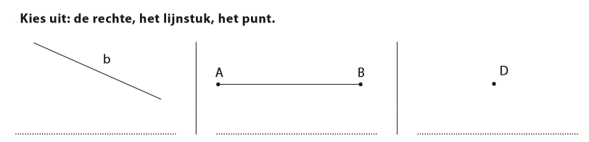

**Kloklezen**

……………………………………….

……………………………………….

……………………………………….

Dagelijkse (reken)kost : woensdag 22 april

**Tafelrijtjes**

|  |  |  |  |
| --- | --- | --- | --- |
| 3 x 4 = ……. | 4 : 4 = ……. |  |  |
| 4 x 4 = ……. | 8 : 4 = ……. |  |  |
| 6 x 4 = ……. | 32 : 4 = ……. |  |  |
| 9 x 4 = ……. | 20 : 4 = ……. |  |  |
| 10 x 4 = ……. | 28 : 4 = ……. |  |  |

**Schrijf tussenstappen!**

|  |
| --- |
| ***Optellen en aftrekken tot 100*** |
| 58 + 28 = ………….…………………….…………………….………… |
| 16 + 29 = ………….………………….……………………….………… |
| 49 + 22 = ………….…………………….…………………….………… |
| 91 – 85 = ………….…………………….…………………….………… |
| 35 – 17 = ………….…………………….…………………….………… |
| 63 – 37 = ………….…………………….…………………….………… |
|  |
|  |
|  |
|  |
|  |
|  |
|  |

**Los al cijferend op.**

**Schat tot op het honderdtal!**

|  |  |  |  |  |
| --- | --- | --- | --- | --- |
| 639 + 223 = | | | | |
| ……….…………… | | | | |
| **TD** | **D** | **H** | **T** | **E** |
|  |  |  |  |  |
|  |  |  |  |  |
|  |  |  |  |  |
|  |  |  |  |  |
|  |  |  |  |  |
|  |  |  |  |  |

**Ik meet lijnen.**

**Teken een rechte van 4 cm.**

**Teken een lijnstuk van 1 dm**

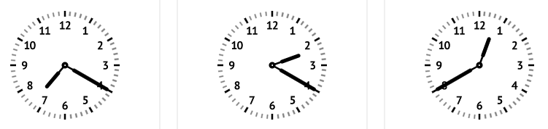

**Kloklezen**

……………………………………….

……………………………………….

……………………………………….

Dagelijkse (reken)kost : donderdag 23 april

**Tafelrijtjes**

|  |  |
| --- | --- |
| 1 x 5 = ……. | 15 : 5 = ……. |
| 6 x 5 = ……. | 50 : 5 = ……. |
| 4 x 5 = ……. | 25 : 5 = ……. |
| 8 x 5 = ……. | 45 : 5 = ……. |
| 2 x 5 = ……. | 35 : 5 = ……. |

**Schrijf tussenstappen!**

|  |
| --- |
| ***Optellen tot 1000*** |
| 801 + 4 = ………….…………………….…………………….………… |
| 311 + 26 = ………….…………………….…………………….………… |
| 211 + 63 = ………….…………………….…………………….………… |
| 598 + 30 = ………….…………………….…………………….………… |
| 819 + 8 = ………….…………………….…………………….………… |
| 435 + 38 = ………….…………………….…………………….………… |
|  |
|  |
|  |
|  |
|  |
|  |
|  |

**Los al cijferend op.**

**Schat tot op het honderdtal!**

|  |  |  |  |  |
| --- | --- | --- | --- | --- |
| 852 – 526 = | | | | |
| ……….…………… | | | | |
| **TD** | **D** | **H** | **T** | **E** |
|  |  |  |  |  |
|  |  |  |  |  |
|  |  |  |  |  |
|  |  |  |  |  |
|  |  |  |  |  |
|  |  |  |  |  |

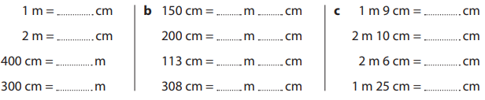

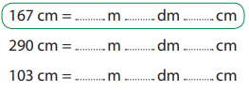

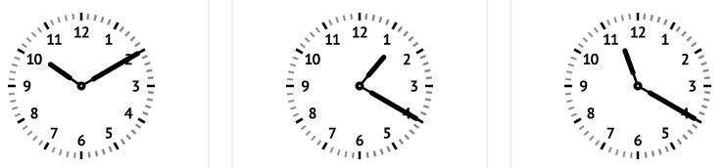

**Kloklezen**

……………………………………….

……………………………………….

……………………………………….

Dagelijkse (reken)kost : vrijdag 24 april

**Tafelrijtjes**

|  |  |
| --- | --- |
| 1 x 6 = ……. | 30 : 6 = ……. |
| 3 x 6 = ……. | 48 : 6 = ……. |
| 10 x 6 = ……. | 12 : 6 = ……. |
| 6 x 6 = ……. | 42 : 6 = ……. |
| 4 x 6 = ……. | 54 : 6 = ……. |

**Schrijf tussenstappen!**

|  |
| --- |
| ***Optellen tot 1000*** |
| 378 + 4 = ………….…………………….………………….……………….. |
| 391 + 26 = ………….…………………….………………….……………….. |
| 248 + 63 = ………….…………………….………………….……………….. |
| 378 + 214 = ………….…………………….………………….……………….. |
| 391 + 256 = ………….…………………….………………….……………….. |
| 248 + 123 = ………….…………………….………………….……………….. |
|  |
|  |
|  |
|  |
|  |
|  |
|  |

**Los al cijferend op.**

**Schat tot op het honderdtal!**

|  |  |  |  |  |
| --- | --- | --- | --- | --- |
| 533 + 198 = | | | | |
| ……….…………… | | | | |
| **TD** | **D** | **H** | **T** | **E** |
|  |  |  |  |  |
|  |  |  |  |  |
|  |  |  |  |  |
|  |  |  |  |  |
|  |  |  |  |  |
|  |  |  |  |  |

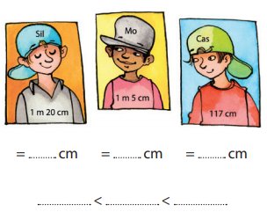

Tip: zet alles eerst in cm

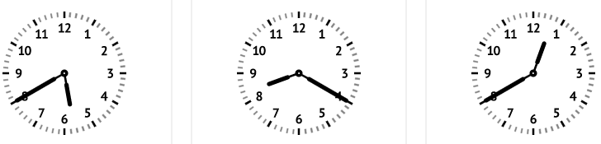

**Kloklezen**

……………………………………….

……………………………………….

……………………………………….

Dagelijkse (reken)kost : maandag 27 april

**Tafelrijtjes**

|  |  |  |  |  |  |
| --- | --- | --- | --- | --- | --- |
| 5 x 7 = ……. | 28 : 7 = ……. |  |  |  |  |
| 8 x 7 = ……. | 49 : 7 = ……. |  |  |  |  |
| 1 x 7 = ……. | 14 : 7 = ……. |  |  |  |  |
| 3 x 7 = ……. | 42 : 7 = ……. |  |  |  |  |
| 9 x 7 = ……. | 70 : 7 = ……. |  |  |  |  |

**Schrijf tussenstappen!**

|  |
| --- |
| ***Optellen tot 1000*** |
| 547 + 130 =………….…………………….………………….……………….. |
| 620 + 177 = ………….…………………….……………….……………….. |
| 647 + 123 =………….…………………….………………….……………….. |
| 420 + 167 = ………….…………………….……………….……………….. |
| 242 + 543 =………….…………………….……………….……………….. |
|  |
|  |
|  |
|  |
|  |
|  |
|  |
|  |

**Los al cijferend op.**

**Schat tot op het honderdtal!**

|  |  |  |  |  |
| --- | --- | --- | --- | --- |
| 546 – 137 = | | | | |
| ……….…………… | | | | |
| **TD** | **D** | **H** | **T** | **E** |
|  |  |  |  |  |
|  |  |  |  |  |
|  |  |  |  |  |
|  |  |  |  |  |
|  |  |  |  |  |
|  |  |  |  |  |

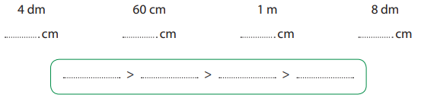

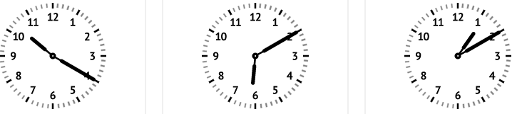

**Kloklezen**

……………………………………….

……………………………………….

……………………………………….

Dagelijkse (reken)kost : dinsdag 28 april

**Tafelrijtjes**

|  |  |  |  |  |  |
| --- | --- | --- | --- | --- | --- |
| 10 x 8 = ……. | 56 : 8 = ……. |  |  |  |  |
| 4 x 8 = ……. | 40 : 8 = ……. |  |  |  |  |
| 1 x 8 = ……. | 64 : 8 = ……. |  |  |  |  |
| 6 x 8 = ……. | 24 : 8 = ……. |  |  |  |  |
| 8 x 8 = ……. | 16 : 8 = ……. |  |  |  |  |

**Schrijf tussenstappen!**

|  |
| --- |
| ***Optellen en aftrekken tot 1000*** |
| 747 + 148 = ………….…………………….…………………….………… |
| 112 + 629 = ………….…………………….…………………….………… |
| 313 + 228 = …………….…………………….…………………….………… |
| 500 - 200 = …………….…………………….…………………….………… |
| 654 - 300 =………….…………………….…………………….………… |
| 552 - 230 = ………….…………………….…………………….………… |
|  |
|  |
|  |
|  |
|  |
|  |
|  |

**Los al cijferend op.**

**Schat tot op het honderdtal!**

|  |  |  |  |  |
| --- | --- | --- | --- | --- |
| 457 + 284 = | | | | |
| ……….…………… | | | | |
| **TD** | **D** | **H** | **T** | **E** |
|  |  |  |  |  |
|  |  |  |  |  |
|  |  |  |  |  |
|  |  |  |  |  |
|  |  |  |  |  |
|  |  |  |  |  |

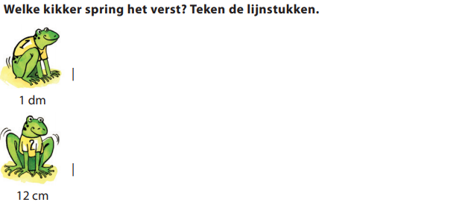

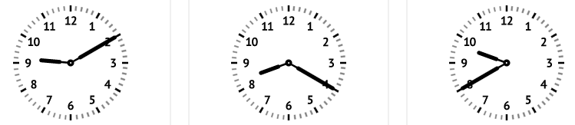

**Kloklezen**

……………………………………….

……………………………………….

……………………………………….

Dagelijkse (reken)kost : woensdag 29 april

**Tafelrijtjes**

|  |  |  |  |
| --- | --- | --- | --- |
| 3 x 9 = ……. | 54 : 9 = ……. |  |  |
| 8 x 9 = ……. | 90 : 9 = ……. |  |  |
| 1 x 9 = ……. | 45 : 9 = ……. |  |  |
| 4 x 9 = ……. | 63 : 9 = ……. |  |  |
| 2 x 9 = ……. | 81 : 9 = ……. |  |  |

**Schrijf tussenstappen!**

|  |
| --- |
| ***Optellen en aftrekken tot 1000*** |
| 395 + 321 = ………….…………………………….…………………….… |
| 590 +199 = ………….…………………………….…………………….… |
| 281 + 153 = ………….…………………………….…………………….… |
| 575 - 190 = ………….…………………………….…………………….… |
| 309 – 109 = ………….…………………………….…………………….… |
| 299 – 290 = ………….…………………………….…………………….… |
|  |
|  |

**Los al cijferend op.**

**Schat tot op het honderdtal!**

|  |  |  |  |  |
| --- | --- | --- | --- | --- |
| 732 – 179 = | | | | |
| ……….…………… | | | | |
| **TD** | **D** | **H** | **T** | **E** |
|  |  |  |  |  |
|  |  |  |  |  |
|  |  |  |  |  |
|  |  |  |  |  |
|  |  |  |  |  |
|  |  |  |  |  |

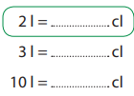 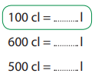 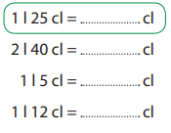

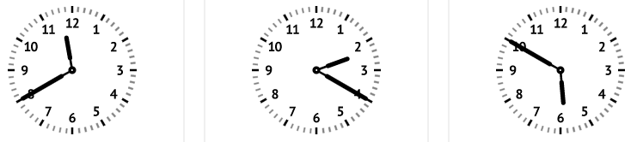

**Kloklezen**

……………………………………….

……………………………………….

……………………………………….

Dagelijkse (reken)kost : donderdag 30 april

**Tafelrijtjes**

|  |  |  |  |
| --- | --- | --- | --- |
| 3 x 6 = ……. | 63 : 9 = ……. |  |  |
| 4 x 2 = ……. | 28 : 7 = ……. |  |  |
| 8 x 7 = ……. | 40 : 5 = ……. |  |  |
| 1 x 5 = ……. | 16 : 4 = ……. |  |  |
| 9 x 0 = ……. | 36 : 6 = ……. |  |  |

**Schrijf tussenstappen!**

|  |
| --- |
| ***Optellen en aftrekken tot 1000*** |
| 270 + 119 = ………….…………………………….…………………….… |
| 692 + 285 = ………….…………………………….…………………….… |
| 211 + 294 = ………….…………………………….…………………….… |
| 337 – 220 = ………….…………………………….…………………….… |
| 518 – 204 = ………….…………………………….…………………….… |
| 678 – 221 = ………….…………………………….…………………….…  Omkring het juiste grondplan |
|  |
|  |
|  |
|  |
|  |
|  |
|  |

**Los al cijferend op.**

**Schat tot op het honderdtal!**

|  |  |  |  |  |
| --- | --- | --- | --- | --- |
| 157 + 568 = | | | | |
| ……….…………… | | | | |
| **TD** | **D** | **H** | **T** | **E** |
|  |  |  |  |  |
|  |  |  |  |  |
|  |  |  |  |  |
|  |  |  |  |  |
|  |  |  |  |  |
|  |  |  |  |  |

